Task A (Exclusion): Find members who have borrowed at least one book but have never borrowed a 'History' book.

Give me all users who have placed orders, but none of their ordered products cost more than 1000.
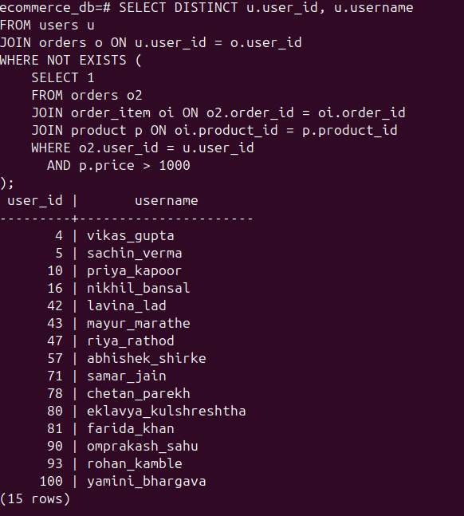

Task B (Pattern Matching): Find books where the Title starts with "The" and ends with "S" (Hint: LIKE).
Give me all products whose name starts with ‘Run’ and ends with ‘en’.

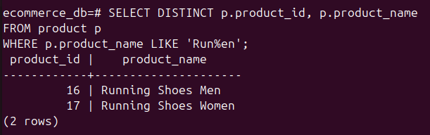

Task C (Range): Find books published between 1990 and 2010 using BETWEEN.

Give me all users who were born in the year 1994.

